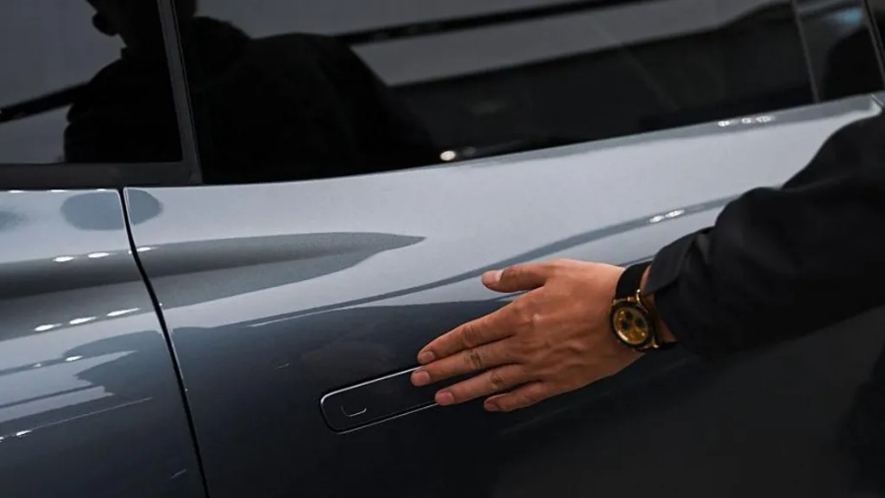
China bans hidden car door handles over safety concerns
3 February 2026
China has banned hidden door handles on electric vehicles (EVs), making it the first country to stop the use of the controversial designs that were made popular by multi-billionaire Elon Musk's Tesla.
It comes as EVs are facing scrutiny from safety watchdogs around the world after a number of deadly incidents, including two fatal crashes in China involving Xiaomi EVs in which power failures were suspected to have prevented doors from being opened.
Under the new regulations, cars will only be allowed to be sold if they have a mechanical release both on the inside and outside of their doors, according to state media.
The new rules are due to take effect on 1 January 2027.
The Ministry of Industry and Information Technology rules require the outside of every passenger door except the boot, to have a recessed space measuring no smaller than 6cm (2 in) by 2cm by 2.5cm to allow access to the handle.
Inside the car there must be signs measuring at least 1cm by 0.7cm to show how to open the door.
Cars that have already been approved by authorities and are in the final stages of entering the Chinese market will have another two years to update their designs.
Hidden handles are widely used in China's new energy vehicle (NEV) market, which includes EVs as well as hybrid cars and those powered by fuel cells.
They feature in about 60% of the top 100 best-selling NEVs, according to data cited by government-controlled newspaper China Daily.
Although the measures will only apply to models sold in the Chinese market, the country's huge presence in the global car industry means the move is likely to have an impact around the world.
Tesla's door handles are already being investigated by US safety regulators and authorities in Europe are considering their own rules.
In November, the US National Highway Traffic Safety Administration (NHTSA) opened a probe focused on Tesla's electric-powered door handles, responding to reports that they suddenly stopped working, leaving children trapped in the cars.
The NHTSA said it had received nine complaints about the handles in Tesla's 2021 Model Y cars, the company's flagship model.
In four of the cases, the car owners resorted to breaking the window to resolve the issue.
https://www.bbc.com/news/articles/cp37g5nxe3lo

Identify which PESTLE factors are most relevant in this case and justify your choices. Are any elements negligible or absent?
Political
Economic
Social
Technological
Legal
Environmental

